EXPERIMENT- 03
Scaling an Image to its Bigger and Smaller Sizes
Aim
To write a Python code to read an image and resize the image into bigger and smaller dimensions using OpenCV image scaling techniques.
Input Image
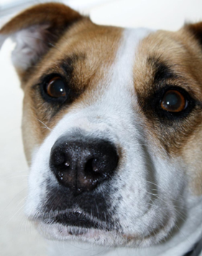
Code
import cv2
from google.colab.patches import cv2_imshow
from google.colab import files
uploaded=files.upload()
image_path=list(uploaded.keys())[0]
img=cv2.imread(image_path)
if img is None:
print("Error: Image not found")
else:
bigger_image=cv2.resize(img,(600,600))
smaller_image=cv2.resize(img,(200,200))
print("Original Image")
cv2_imshow(img)
print("Bigger Image")
cv2_imshow(bigger_image)
print("Smaller Image")
cv2_imshow(smaller_image)
Output Image
Scaled Images
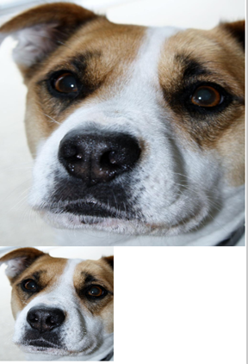
Result
Thus, the image was successfully resized into bigger and smaller dimensions using OpenCV.

